

DATA STRUCTURES & ALGORITHMS
23CSE203
LAB MANUAL
Submitted By
Name | Sush
Roll No. | AV.SC.U4CSE25023
Year/Sem/Section | 2nd year /Sem-3/CSE-A
Credits | 05

S.No. | Title | Page No.
1) | Week-1:  1A) Rocket launch systems display the countdown of before launch instead of using a loop implement the countdown using the recursion write a recursion Python program to display the countdown from n to 1 followed by launch.  1B) Banks calculate the growth of an investment using compound interest. The formula requires calculating powers, which can be implemented recursively. Write a recursive Python program to calculate P^n (power), where P = Principal growth factor, n = number of years.  1C) An HR department stores employee IDs in a list. Develop a recursive program to search for a given employee ID. Write a recursive function to search for an employee ID in a list.  1D) In a logistics company, the number of possible ways to arrange n different parcels is calculated using the factorial formula. Develop a recursive program to calculate the factorial of a given number.  1E) Write a recursive Python program to print the first n terms of a Fibonacci series. | 3-12
INDEX

WEEK-1

1A) Aim: Rocket launch systems display the countdown of before launch instead of using a loop implement the countdown using the recursion write a recursion Python program to display the countdown from n to 1 followed by launch.

Program:
def print_countdown(n):
if n < 0:
return
print(n)
print_countdown(n-1)

print_countdown(10)
print("LAUNCH")
Output:
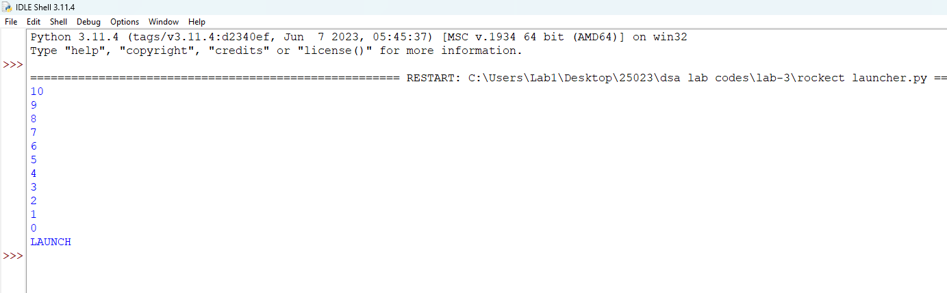

Explanation:
- def defines the countdown() function.
- input() accepts the countdown value from the user.
- int() converts the input into an integer.
- countdown() starts the recursive countdown process.
- if checks the base case (n == 0).
- else executes when the condition is False.
- print(n) displays the current countdown number.
- countdown(n - 1) recursively calls the function with the value decreased by 1.
- print("Launch!") displays the launch message when the countdown reaches 0.
- The program demonstrates the use of functions, recursion, conditional statements, input, and output to perform the countdown.
Error Table:
S.No. | Errors Observed | Rectification
1) | Count down does not stop | Check the condition when n reaches to zero.
2) | Program starts from a very large number | Cjeck the condtion when n reaches to zero
3) | incorrect indentation leading to an Indentation Error | Maintain proper Python indentation.

1B) Aim: Banks calculate the growth of an investment using compound interest. The formula requires calculating powers, which can be implemented recursively. Write a recursive Python program to calculate P^n (power), where P = Principal growth factor, n = number of years.

Program:
def power (n,p):

if p == 0:
return 1
return n * power(n,p-1)
print(power(5,3))
Output:
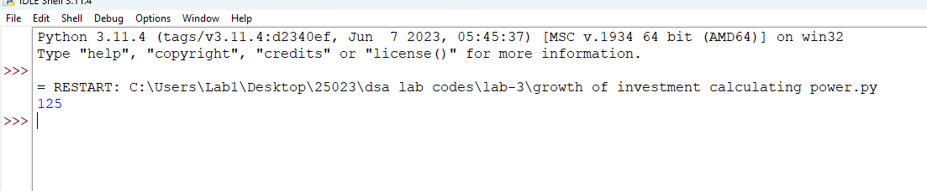

Explanation:
- power() is the recursive function that computes n raised to p.
- The base case is p == 0, which returns 1 (any number to the power 0 is 1).
- The recursive case multiplies p with power(p, n - 1), reducing n by 1 on each call.
- float() allows the principal growth factor to be a decimal value.
- input() collects the values of P and n from the user.
- Each recursive call is stacked until the base case is reached, then the results are multiplied back up the call stack.
- print() displays the final computed value of P^n.
Error Table:
S.No. | Errors Observed | Rectification
1) | Missing base case (n == 0) causing infinite recursion. | Include the base case to stop recursion.
2) | Entering a negative value for n causes the recursion to never reach 0. | Restrict input to non-negative integers or handle negative n separately.
3) | Using int() for P truncates decimal growth factors. | Use float() to accept decimal values for P.
4) | Incorrect indentation leading to an IndentationError. | Maintain proper Python indentation.
5) | Calling power(p, n) instead of power(n, p - 1), causing infinite recursion. | Decrease n by 1 in each recursive call using power(n, p- 1).

1C) Aim: An HR department stores employee IDs in a list. Develop a recursive program to search for a given employee ID. Write a recursive function to search for an employee ID in a list.
Program:
def search(arr,target,s):

if (arr[s]==target):
return s
if(s==0 and arr[s]!=target):
return -1

return search(arr,target,s-1)

arr = [3,45,233,5,6,89,32,4,23,32]
print(search(arr,10,len(arr)-1))
Output:
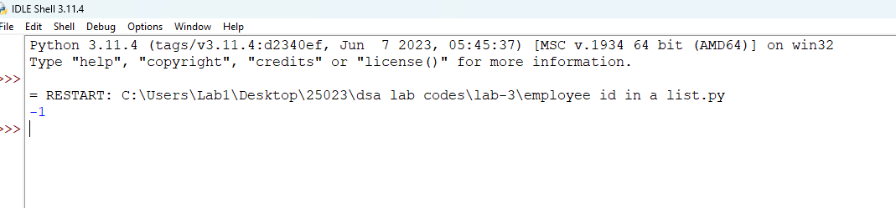
Explanation:
- search_employee() is the recursive function that searches the list one index at a time.
- The base case index == len(emp_list) means every element was checked and the ID was not found, so it returns -1.
- The second condition checks if the current element matches the employee ID being searched.
- If not matched, the function calls itself with index + 1, moving to the next employee in the list.
- employee_ids is the list of employee IDs stored by the HR department.
- input() and int() collect the employee ID to search for from the user.
- The if-else block reports whether the employee ID was found and at which position.
Error Table:
S.No. | Errors Observed | Rectification
1) | Invalid (non-numeric) input entered by the user. | Enter a valid integer as input.
2) | Incorrect indentation leading to an IndentationError. | Maintain proper Python indentation.
3) | Searching an empty list without handling it, giving a confusing result. | Add a check for an empty list before searching.

1D) Aim:In a logistics company, the number of possible ways to arrange n different parcels is calculated using the factorial formula. Develop a recursive program to calculate the factorial of a given number.
Program:
def fact(n):

if(n==0):
return 1
return n*fact(n-1);
print(fact(7))
Output:
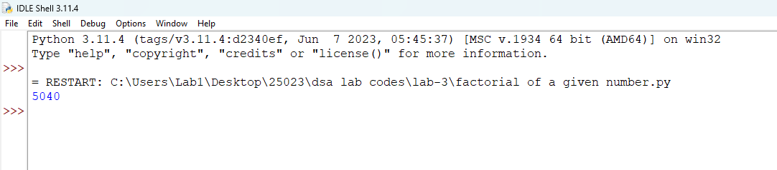

Explanation:
- factorial() is the recursive function that computes n! (n factorial).
- The base case is n == 0 or n == 1, both of which return 1.
- The recursive case multiplies n with factorial(n - 1), reducing n by 1 on each call.
- input() and int() collect the number whose factorial is to be found.
- Each recursive call is stacked until the base case is reached, then the results are multiplied back up the call stack.
- print() displays the number of possible arrangements (the factorial value).
Error Table:
S.No. | Errors Observed | Rectification
1) | Missing base case (n == 0 or n == 1) causing infinite recursion. | Include the base case to stop recursion.
2) | Entering a negative number, for which factorial is undefined. | Restrict input to non-negative integers.
3) | Invalid (non-numeric) input entered by the user. | Enter a valid integer as input.
4) | Incorrect indentation leading to an IndentationError. | Maintain proper Python indentation.
5) | Calling factorial(n) instead of factorial(n - 1), causing infinite recursion. | Decrease n by 1 in each recursive call using factorial(n - 1).

1E) Aim:Write a recursive Python program to print the first n terms of a Fibonacci series.

Program:
def fib(n):

if n==1:
return 0
if n==2:
return 1

return fib(n-1) + fib(n-2)
def fibseries(n):
for i in range (1,n+1):
print(fib(i))

return "Done"

print(fibseries(5))

Output:
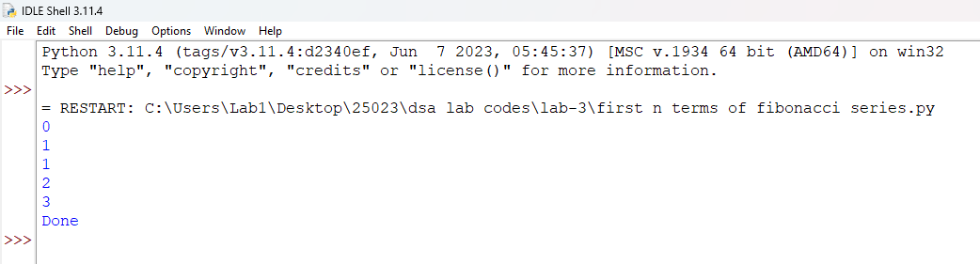

Explanation:
- fibonacci() is the recursive function that returns the nth Fibonacci term.
- The base cases are n == 0 (returns 0) and n == 1 (returns 1).
- The recursive case adds fibonacci(n - 1) and fibonacci(n - 2), following the Fibonacci rule.
- input() and int() collect the number of terms to be printed.
- The for loop calls fibonacci(i) for each index from 0 to n - 1.
- print(..., end=" ") displays each term on the same line, separated by a space.
Error Table:
S.No. | Errors Observed | Rectification
1) | Missing base cases (n == 0 and n == 1) causing infinite recursion. | Include both base cases to stop recursion.
2) | Entering a negative number of terms. | Restrict input to non-negative integers.
3) | Invalid (non-numeric) input entered by the user. | Enter a valid integer as input.
4) | Incorrect indentation leading to an IndentationError. | Maintain proper Python indentation.
5) | Using fibonacci(n - 1) - fibonacci(n - 2) instead of addition, giving wrong terms. | Use addition, fibonacci(n - 1) + fibonacci(n - 2), as per the Fibonacci rule.

WEEK-2

2A) Aim: Write a python program to perform linear search on the given input.
Program:
def linear_search(arr):
key=int(input("enter a number to check:"))
found =False
for i in range (len(arr)):
if arr[i] == key:
print(f"{key} is found at index",i)
found=True
break
if found == False:
print(f"{key} is not found")

l=int(input(f"enter total numbers of elements:"))
arr=[]

for i in range(l):
a=int(input("enter the element found to be :"))
arr.append(a)
linear_search(arr)
Output:

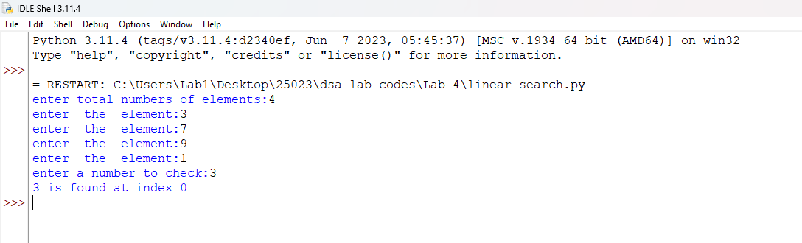

Explanation:
- linear_search(arr, target) sequentially iterates through arr to check each element against target.
- for i in range(n): iterates through array indices from 0 to n-1 sequentially.
- if arr[i] == target: checks for a match and returns index i if found.
- return -1 executes when the target element is absent from the array.
- arr.append(int(input())) converts user input to integers and builds the array.
- if (result != -1): displays the index where the element is found or prints a "not found" message.
Error Table:
S.No. | Errors Observed | Rectification
1) | Invalid (non-numeric) input entered by the user. | Entered a valid integer as input.
2) | Incorrect indentation leading to an Indentation Error | Maintained proper Python indentation.
3) | Missing colon (:) after def, for, if, or else. | Added the required colon (:) after statements.
4) | ValueError when passing non-integer strings to int(input()). | Ensure user input consists of valid integer characters.
5) | IndexError caused by accessing an array index out of bounds. | Ensure loop bounds do not exceed len(arr) - 1.

2B) Aim: Write a python program to perform binary search on the given input.Verify by taking sorted array and unsorted array as input.
Program:
def binary_search(arr):
low=0
high=len(arr)-1
key=int(input("enter a number to search:"))
found=False

while low <= high:

mid= (low+high)//2
if arr [mid] ==key:
print(f"{key} is found at index:",mid)
found=True
break
elif arr[mid] > key:
high =mid-1

elif arr[mid] < key:
low=mid+1

if found == False:
print(f"{key} is not found")

l= int(input("enter a total number of elemants:"))
arr = []

for i in range (l):
a=int(input(f"Enter {i+1}st elements:"))
arr.append(a)
arr.sort()

binary_search(arr)
Output:
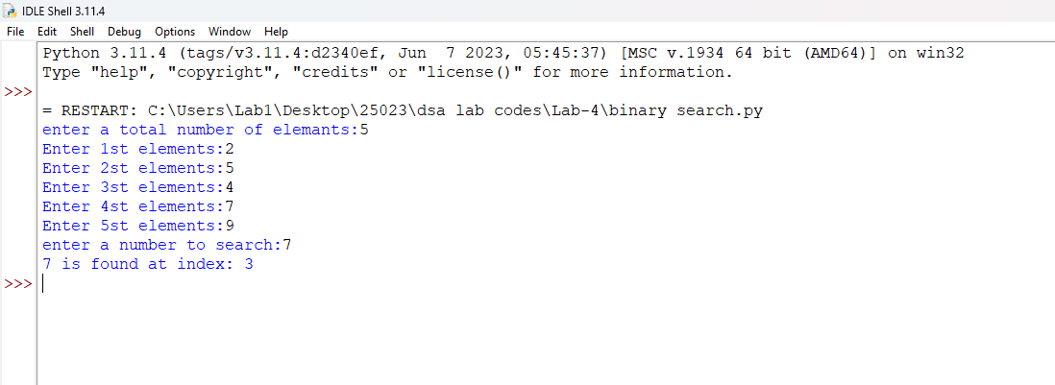
Explanation:
- binary_search(arr, target) uses a divide-and-conquer strategy on a sorted array.
- while low <= high: runs as long as the search boundary contains valid elements.
- mid = (low + high) // 2 computes the middle index using integer division.
- if arr[mid] == target: returns mid if the target is found at the middle index.
- elif arr[mid] < target: updates low = mid + 1, otherwise sets high = mid - 1.
- arr.sort() ensures the input array is sorted before executing binary search.
Error Table:
S.No. | Errors Observed | Rectification
1) | Performing binary search on an unsorted array leading to incorrect results. | Sort the array using arr.sort() before applying binary search.
2) | Using floating-point division / instead of integer division // for calculating mid, causing a TypeError. | Use mid = (low + high) // 2 for integer index calculation.
3) | Incorrect loop condition (low < high instead of low <= high), missing target when low == high. | Change the condition to while low <= high:.
4) | Incorrectly updating pointers like low = mid or high = mid causing an infinite loop. | Use low = mid + 1 and high = mid - 1.
5) | Invalid (non-numeric) input entered by the user. | Enter a valid integer as input.

Week 3

- write a python program to sort the elements using bubble sort technique take an input elements from the user

code:
n = int(input("Enter the number of elements: "))

arr = []

for i in range(n):
element = int(input(f"Enter element {i + 1}: "))
arr.append(element)
for i in range(n - 1):
for j in range(n - i - 1):
if arr[j] > arr[j + 1]:

arr[j], arr[j + 1] = arr[j + 1], arr[j]

print("Elements after Bubble Sort:")
print(arr)

output:
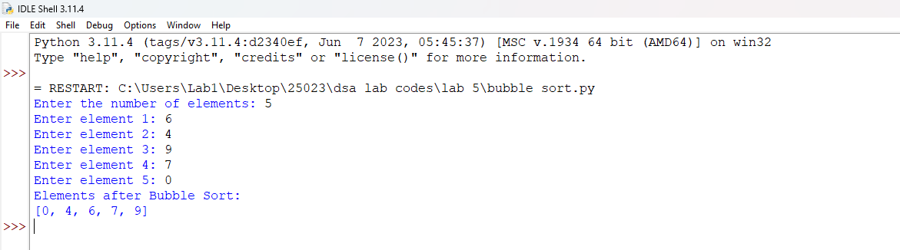
- write a python program to sort the elements using insertion sort technique take an input elements from the user
code:
n = int(input("Enter the number of elements: "))

arr = []

for i in range(n):
element = int(input(f"Enter element {i + 1}: "))
arr.append(element)

for i in range(1, n):
key = arr[i]
j = i - 1

while j >= 0 and arr[j] > key:
arr[j + 1] = arr[j]
j = j - 1

arr[j + 1] = key

print("Sorted elements are:", arr)

output
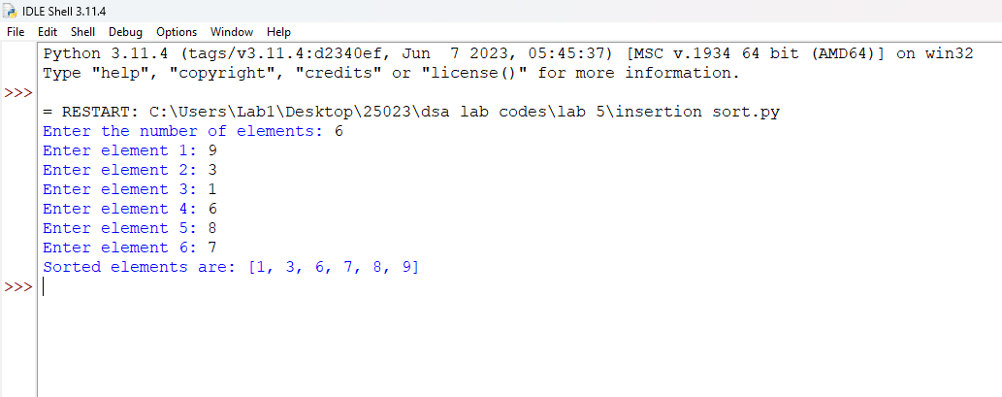
3)write a python program to sort the elements using selection sort technique take an input elements from the user
Code:
# Selection Sort in Python
n = int(input("Enter the number of elements: "))

arr = []

for i in range(n):
element = int(input(f"Enter element {i + 1}: "))
arr.append(element)

for i in range(n - 1):
min_index = i
for j in range(i + 1, n):
if arr[j] < arr[min_index]:
min_index = j

arr[i], arr[min_index] = arr[min_index], arr[i]

print("Sorted elements are:", arr)

output:
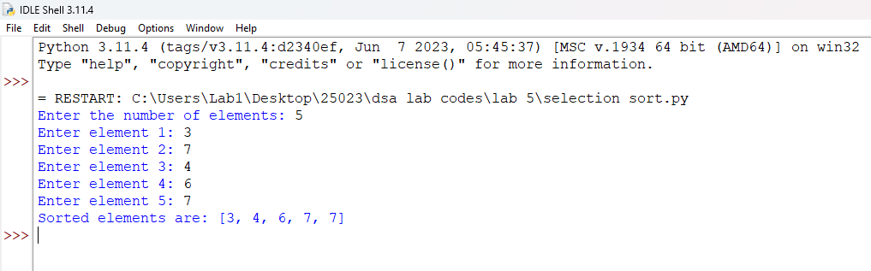

- write a python program to sort the elements using merge sort technique take an input elements from the user
code:
def merge_sort(arr):
if len(arr) > 1:
mid = len(arr) // 2

left = arr[:mid]
right = arr[mid:]

merge_sort(left)
merge_sort(right)

i = j = k = 0

while i < len(left) and j < len(right):
if left[i] < right[j]:
arr[k] = left[i]
i += 1
else:
arr[k] = right[j]
j += 1
k += 1

while i < len(left):
arr[k] = left[i]
i += 1
k += 1

while j < len(right):
arr[k] = right[j]
j += 1
k += 1

n = int(input("Enter the number of elements: "))

arr = []

for i in range(n):
element = int(input(f"Enter element {i + 1}: "))
arr.append(element)

print("Original array:", arr)
merge_sort(arr)

print("Sorted array:", arr)
output:
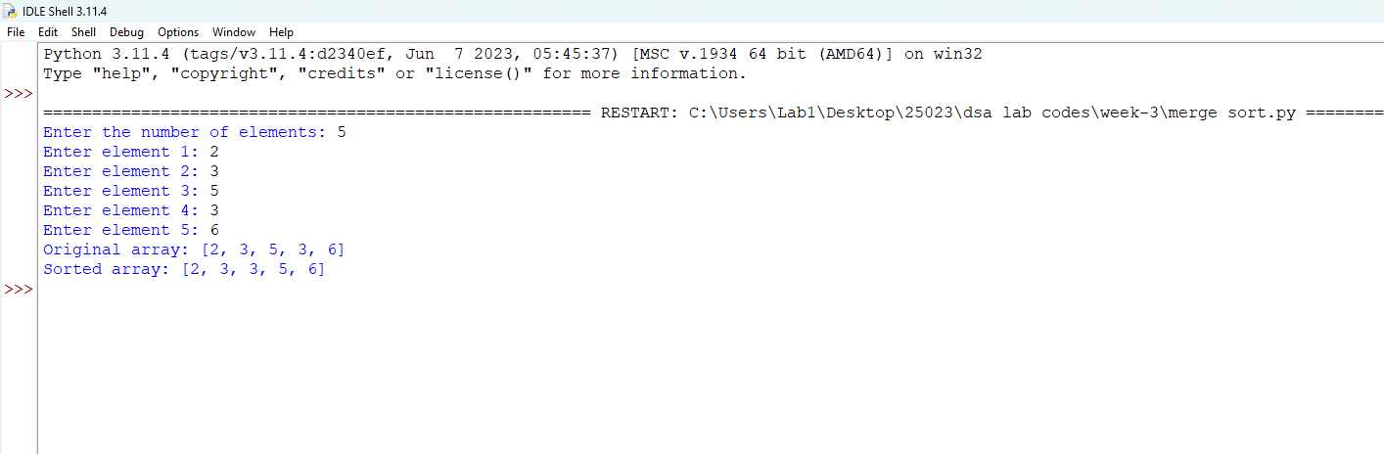

Week-4

Aim: Write a menu-driven Python program to implement a Circular Linked List using classes Node and LinkedList.
The program should support the following operations:
- Create a linked list with n nodes.
- Insert a node at the beginning.
- Insert a node at the end.
- Insert a node at a specific index.
- Delete a node from a specific index.
- Delete the first node.
- Delete the last node.
- Count the number of nodes in the linked list.
- Display/traverse the linked list.
- Exit the program.
Program:
class Node:
def __init__(self, data):
self.data = data
self.next = None

class LinkedList:
def __init__(self):
self.head = None

# 1. Create a linked list
def create(self):
n = int(input("Enter number of nodes: "))

for i in range(n):
data = int(input("Enter value: "))
new_node = Node(data)

if self.head is None:
self.head = new_node
else:
temp = self.head
while temp.next is not None:
temp = temp.next
temp.next = new_node

# 2. Insert at beginning
def insert_beginning(self):
data = int(input("Enter value: "))
new_node = Node(data)

new_node.next = self.head
self.head = new_node

# 3. Insert at end
def insert_end(self):
data = int(input("Enter value: "))
new_node = Node(data)

if self.head is None:
self.head = new_node
return

temp = self.head
while temp.next is not None:
temp = temp.next

temp.next = new_node

# 4. Insert at a specific index
def insert_index(self):
data = int(input("Enter value: "))
index = int(input("Enter index: "))

new_node = Node(data)

if index == 0:
new_node.next = self.head
self.head = new_node
return

temp = self.head
prev = None
count = 0

while temp is not None and count < index:
prev = temp
temp = temp.next
count += 1

if count != index:
print("Invalid index")
return

prev.next = new_node
new_node.next = temp

# 5. Delete at a specific index
def delete_index(self):
index = int(input("Enter index to delete: "))

if self.head is None:
print("List is empty")
return

if index == 0:
self.head = self.head.next
return

temp = self.head
prev = None
count = 0

while temp is not None and count < index:
prev = temp
temp = temp.next
count += 1

if temp is None:
print("Invalid index")
return

prev.next = temp.next

# 6. Delete first node
def delete_first(self):
if self.head is None:
print("List is empty")
return

self.head = self.head.next

# 7. Delete last node
def delete_last(self):
if self.head is None:
print("List is empty")
return

if self.head.next is None:
self.head = None
return

temp = self.head

while temp.next.next is not None:
temp = temp.next

temp.next = None

# 8. Count number of nodes
def count_nodes(self):
count = 0
temp = self.head

while temp is not None:
count += 1
temp = temp.next

print("Number of nodes:", count)

# 9. Display / Traverse
def display(self):
if self.head is None:
print("List is empty")
return

temp = self.head

while temp is not None:
print(temp.data, end=" -> ")
temp = temp.next

print("None")

# Main program
linked_list = LinkedList()

while True:
print("\n----- SINGLY LINKED LIST -----")
print("1. Create a linked list")
print("2. Insert at beginning")
print("3. Insert at end")
print("4. Insert at a specific index")
print("5. Delete at a specific index")
print("6. Delete first node")
print("7. Delete last node")
print("8. Count number of nodes")
print("9. Display / Traverse")
print("10. Exit")

choice = int(input("Enter your choice: "))

if choice == 1:
linked_list.create()

elif choice == 2:
linked_list.insert_beginning()

elif choice == 3:
linked_list.insert_end()

elif choice == 4:
linked_list.insert_index()

elif choice == 5:
linked_list.delete_index()

elif choice == 6:
linked_list.delete_first()

elif choice == 7:
linked_list.delete_last()

elif choice == 8:
linked_list.count_nodes()

elif choice == 9:
linked_list.display()

elif choice == 10:
print("Exiting...")
break

else:
print("Invalid choice")

Output:
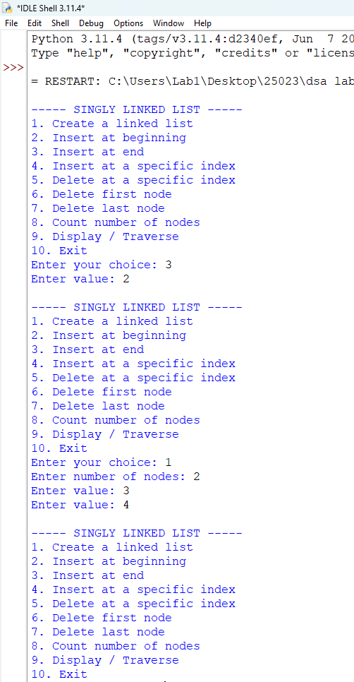
Singly Linked List — Code Explanation
- Node class creates each node with two parts: data and next.
- LinkedList class maintains the linked list using a head pointer.
- create() creates n nodes and connects each new node to the previous node.
- insert_beginning() creates a node and places it before the current head.
- insert_end() traverses to the last node and attaches the new node there.
- insert_index() traverses to the required position and inserts the new node between two nodes.
- delete_index() removes the node at the given index by changing the previous node's next pointer.
- delete_first() and delete_last() remove the first and last nodes respectively.
- count_nodes() traverses the list and counts every node until None is reached.
- display() traverses from head to None and prints all node values.

Errors Encountered:

S.No | Error Observed | Rectification
1 | self.head is not initialized. | Add self.head = None in the LinkedList constructor.
2 | insert_end() does not handle an empty list. | If self.head is None, set self.head = new_node and return.
3 | insert_index() does not handle index 0. | Handle index == 0 separately as insertion at the beginning.
4 | delete_last() fails for a single-node list. | If self.head.next is None, set self.head = None.
5 | display() does not move temp to the next node. | Add temp = temp.next inside the traversal loop.

WEEK-5
Aim: Write a menu-driven Python program to implement a Circular Linked List using classes Node and LinkedList.
The program should support the following operations:
- Create a linked list with n nodes.
- Insert a node at the beginning.
- Insert a node at the end.
- Insert a node at a specific index.
- Delete a node from a specific index.
- Delete the first node.
- Delete the last node.
- Count the number of nodes in the linked list.
- Display/traverse the linked list.
- Exit the program.
Program:
class Node:
def __init__(self, data):
self.data = data
self.next = None

class CircularLinkedList:
def __init__(self):
self.head = None

# 1. Create a circular linked list
def create(self):
n = int(input("Enter number of nodes: "))

for i in range(n):
data = int(input("Enter value: "))
new_node = Node(data)

if self.head is None:
self.head = new_node
new_node.next = self.head
else:
temp = self.head

while temp.next != self.head:
temp = temp.next

temp.next = new_node
new_node.next = self.head

# 2. Insert at beginning
def insert_beginning(self):
data = int(input("Enter value: "))
new_node = Node(data)

# Empty list
if self.head is None:
self.head = new_node
new_node.next = self.head
return

# Find last node
temp = self.head

while temp.next != self.head:
temp = temp.next

new_node.next = self.head
temp.next = new_node
self.head = new_node

# 3. Insert at end
def insert_end(self):
data = int(input("Enter value: "))
new_node = Node(data)

# Empty list
if self.head is None:
self.head = new_node
new_node.next = self.head
return

# Find last node
temp = self.head

while temp.next != self.head:
temp = temp.next

temp.next = new_node
new_node.next = self.head

# 4. Insert at a specific index
def insert_index(self):
data = int(input("Enter value: "))
index = int(input("Enter index: "))

new_node = Node(data)

# Insert at beginning
if index == 0:
if self.head is None:
self.head = new_node
new_node.next = self.head
return

temp = self.head

while temp.next != self.head:
temp = temp.next

new_node.next = self.head
temp.next = new_node
self.head = new_node
return

# Empty list
if self.head is None:
print("Invalid index")
return

temp = self.head
count = 0

# Move to node before required index
while count < index - 1:
temp = temp.next
count += 1

if temp == self.head:
print("Invalid index")
return

new_node.next = temp.next
temp.next = new_node

# 5. Delete at a specific index
def delete_index(self):
index = int(input("Enter index to delete: "))

if self.head is None:
print("List is empty")
return

# Delete first node
if index == 0:
self.delete_first()
return

temp = self.head
count = 0

# Find node before the node to delete
while count < index - 1:
temp = temp.next
count += 1

if temp == self.head:
print("Invalid index")
return

# If next node is head, index is invalid
if temp.next == self.head:
print("Invalid index")
return

temp.next = temp.next.next

# 6. Delete first node
def delete_first(self):
if self.head is None:
print("List is empty")
return

# Only one node
if self.head.next == self.head:
self.head = None
return

# Find last node
temp = self.head

while temp.next != self.head:
temp = temp.next

temp.next = self.head.next
self.head = self.head.next

# 7. Delete last node
def delete_last(self):
if self.head is None:
print("List is empty")
return

# Only one node
if self.head.next == self.head:
self.head = None
return

temp = self.head

# Find second-last node
while temp.next.next != self.head:
temp = temp.next

temp.next = self.head

# 8. Count number of nodes
def count_nodes(self):
if self.head is None:
print("Number of nodes: 0")
return

count = 0
temp = self.head

while True:
count += 1
temp = temp.next

if temp == self.head:
break

print("Number of nodes:", count)

# 9. Display / Traverse
def display(self):
if self.head is None:
print("List is empty")
return

temp = self.head

while True:
print(temp.data, end=" -> ")
temp = temp.next

if temp == self.head:
break

print("(head)")

# Main program
circular_list = CircularLinkedList()

while True:
print("\n----- CIRCULAR LINKED LIST -----")
print("1. Create a circular linked list")
print("2. Insert at beginning")
print("3. Insert at end")
print("4. Insert at a specific index")
print("5. Delete at a specific index")
print("6. Delete first node")
print("7. Delete last node")
print("8. Count number of nodes")
print("9. Display / Traverse")
print("10. Exit")

choice = int(input("Enter your choice: "))

if choice == 1:
circular_list.create()

elif choice == 2:
circular_list.insert_beginning()

elif choice == 3:
circular_list.insert_end()

elif choice == 4:
circular_list.insert_index()

elif choice == 5:
circular_list.delete_index()

elif choice == 6:
circular_list.delete_first()

elif choice == 7:
circular_list.delete_last()

elif choice == 8:
circular_list.count_nodes()

elif choice == 9:
circular_list.display()

elif choice == 10:
print("Exiting...")
break

else:
print("Invalid choice")

output
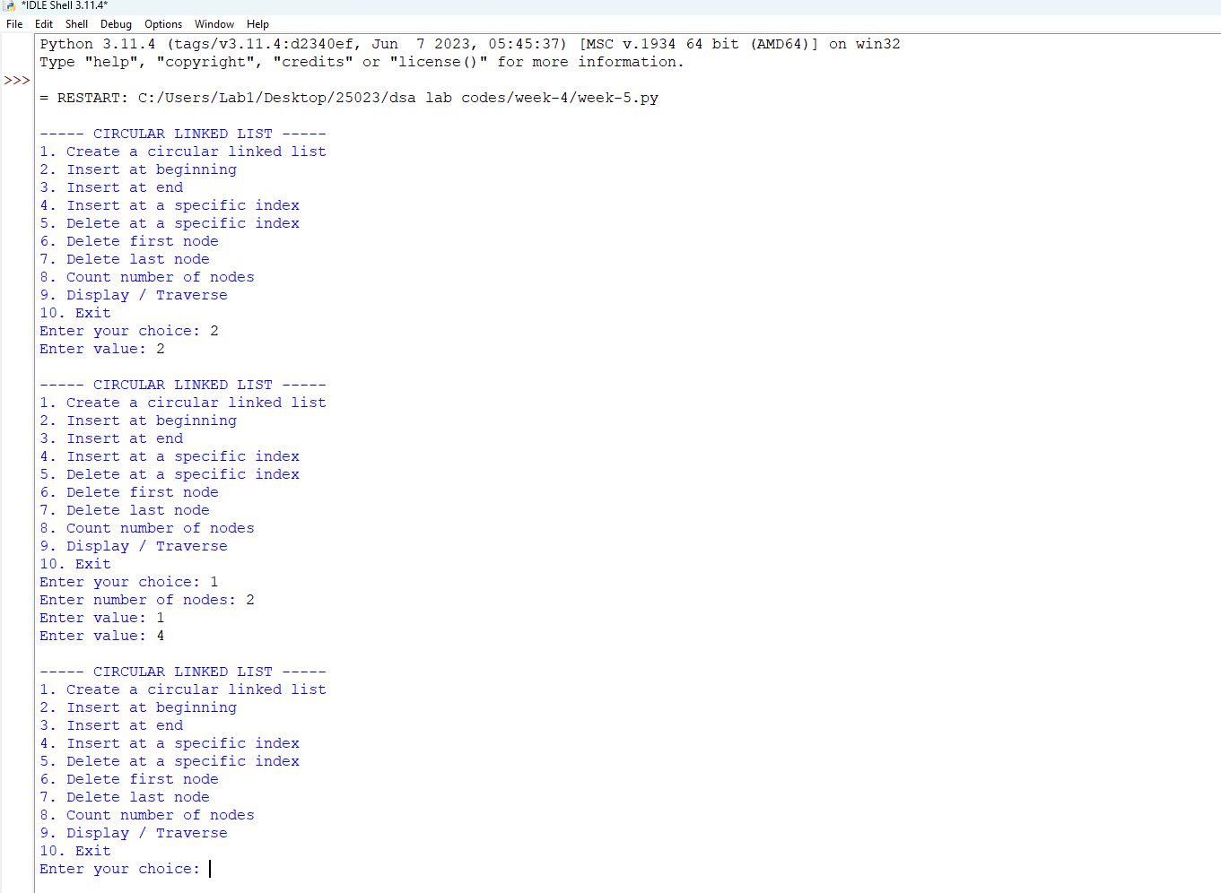
Circular Linked List — Code Explanation
- Node class creates each node with data and a next pointer.
- CircularLinkedList class maintains the list using a head pointer.
- In a circular list, the last node always points back to head, instead of None.
- create() creates nodes and connects the final node back to head.
- insert_beginning() adds a node before head and updates the last node to point to the new head.
- insert_end() finds the last node, adds the new node, and makes it point to head.
- insert_index() traverses to the required position and connects the new node into the circular chain.
- delete_index(), delete_first(), and delete_last() remove nodes while maintaining the circular connection.
- count_nodes() counts nodes until traversal reaches head again.
- display() prints nodes until it reaches head again, preventing an infinite loop.
Errors Encountered:

S.No | Error Observed | Rectification
1 | First node does not point back to head. | Set new_node.next = self.head when creating the first node.
2 | while temp is not None is used to find the last node. | Use while temp.next != self.head:.
3 | Circular traversal causes an infinite loop. | Stop traversal when temp == self.head again.
4 | delete_first() does not update the last node. | Set the last node's next to the new head.
5 | Single-node circular list is not handled during deletion. | Check self.head.next == self.head and set self.head = None.

